Final Report

Website for our Classes (tuition) service

1. Introduction

* Our project had the aim to realize a web portal for our website and create an access point for our customers to our service. The website was supposed to create ease of life and improve the customer experience of all of our clients while also representing us in the most suitable manner.

2. Design and Implementation

* Our web portal can better communicate the services that our Classes provides to any potential customers.  
  Some of its features include:  
  - A method to contact us with a form available at the contact page  
  - The ability to learn about the admission process and submit an online application  
  - An extensive catalogue to showcase our professors  
  - An extensive catalogue to showcase our courses
* All of these above designs and features were implemented using simple bootstrap and we tried our best not to over complicate the matter.  
  using simple codes and simple modes of coding we were able to achieve our goal as well as make sure that everything is up to standard
* Details of how we converted from design to the actual realization of your project in terms of implementing the code can be found in our github repository mentioned below.
* All choices that we made, and any modifications that we made to the design, in response to difficulties that you might have encountered while implementing the project were to a minimum and not worth the mention. It was all technical in expertise that we had to educate ourselves for
* A brief discussion of various modules and libraries that we used in implementing our project. Highlights are shown below in use in these screenshots:

(conclusions and reference are provided after the screenshots)

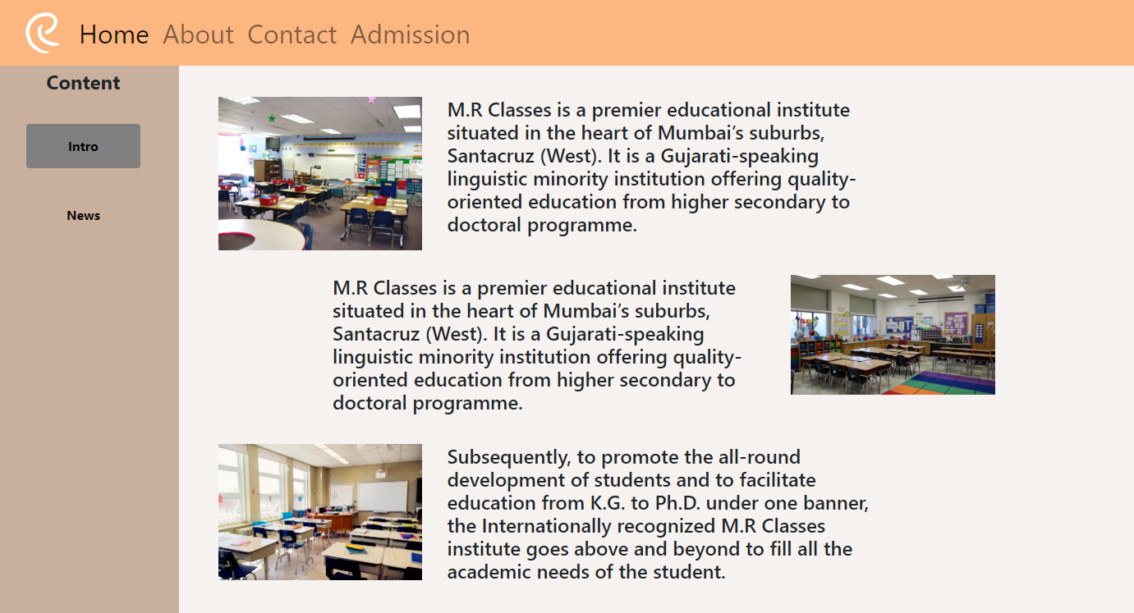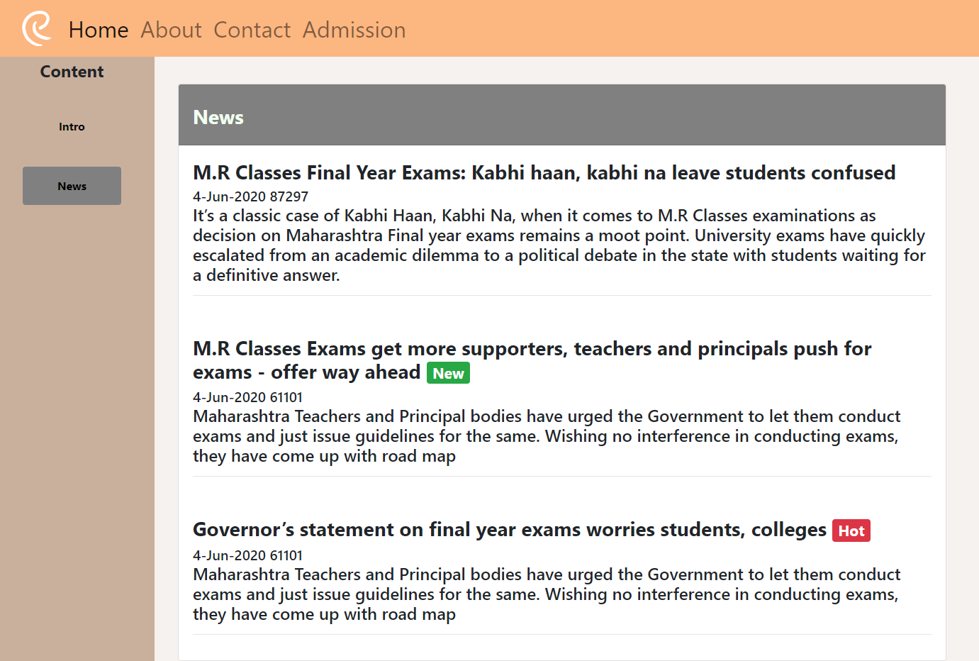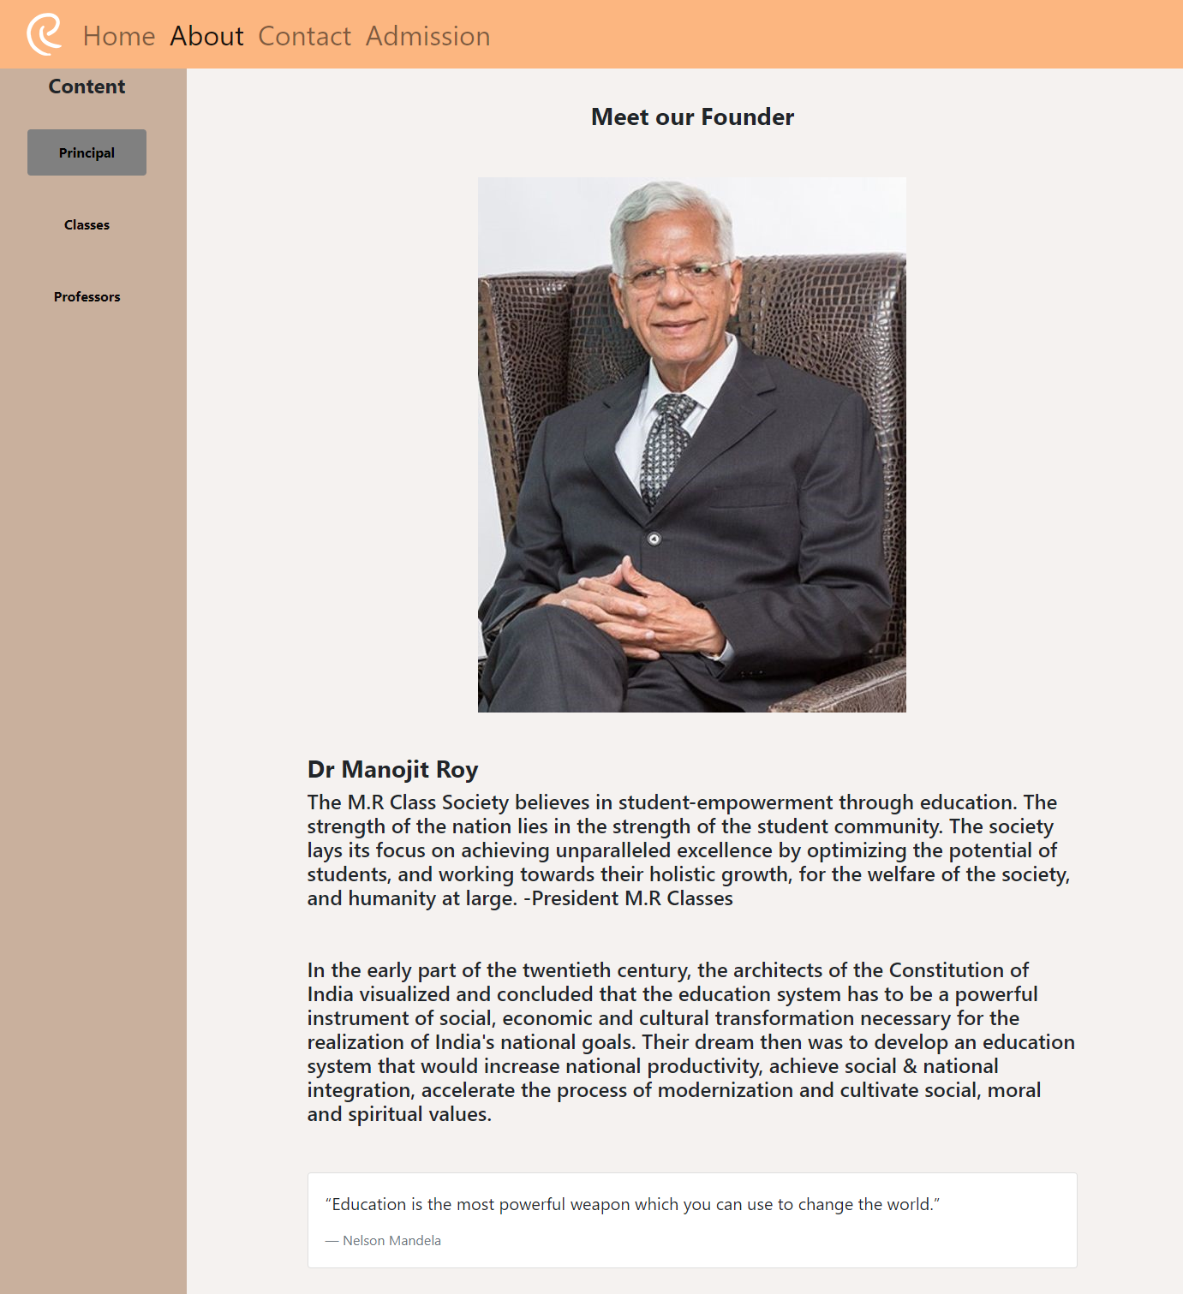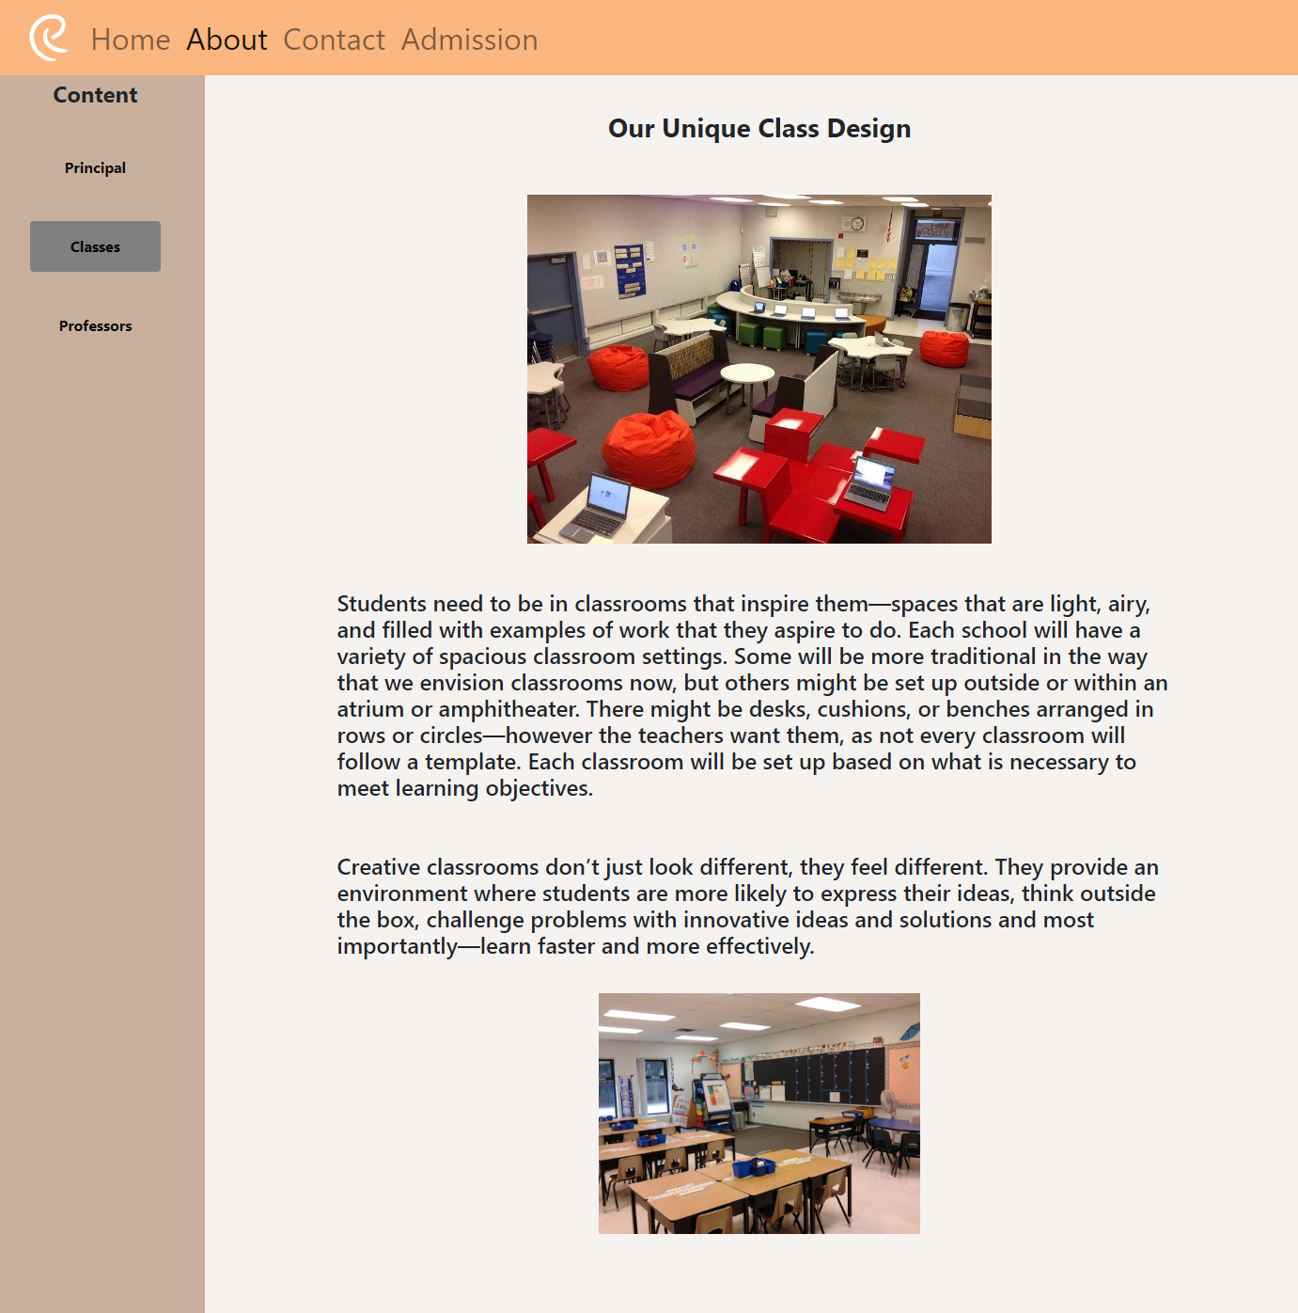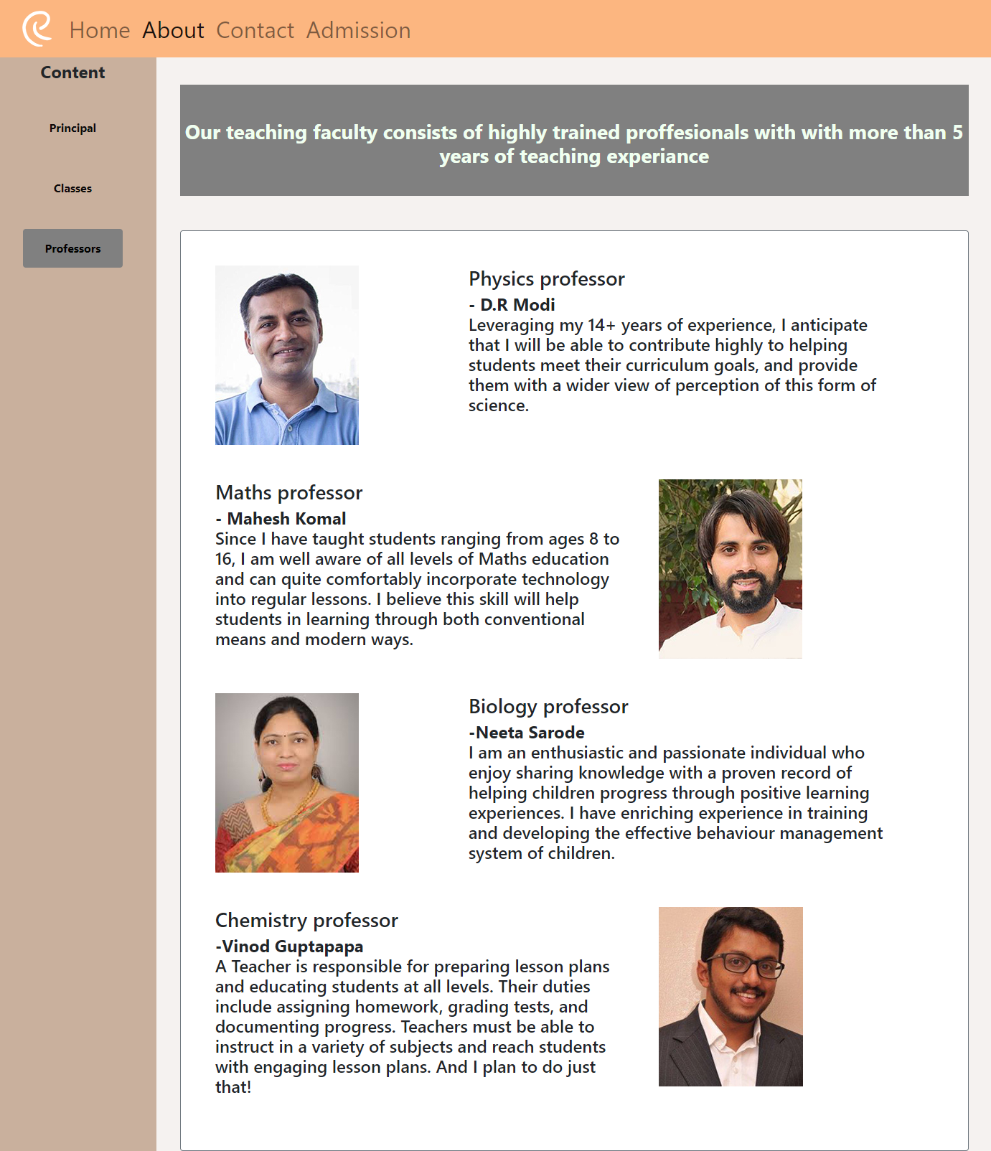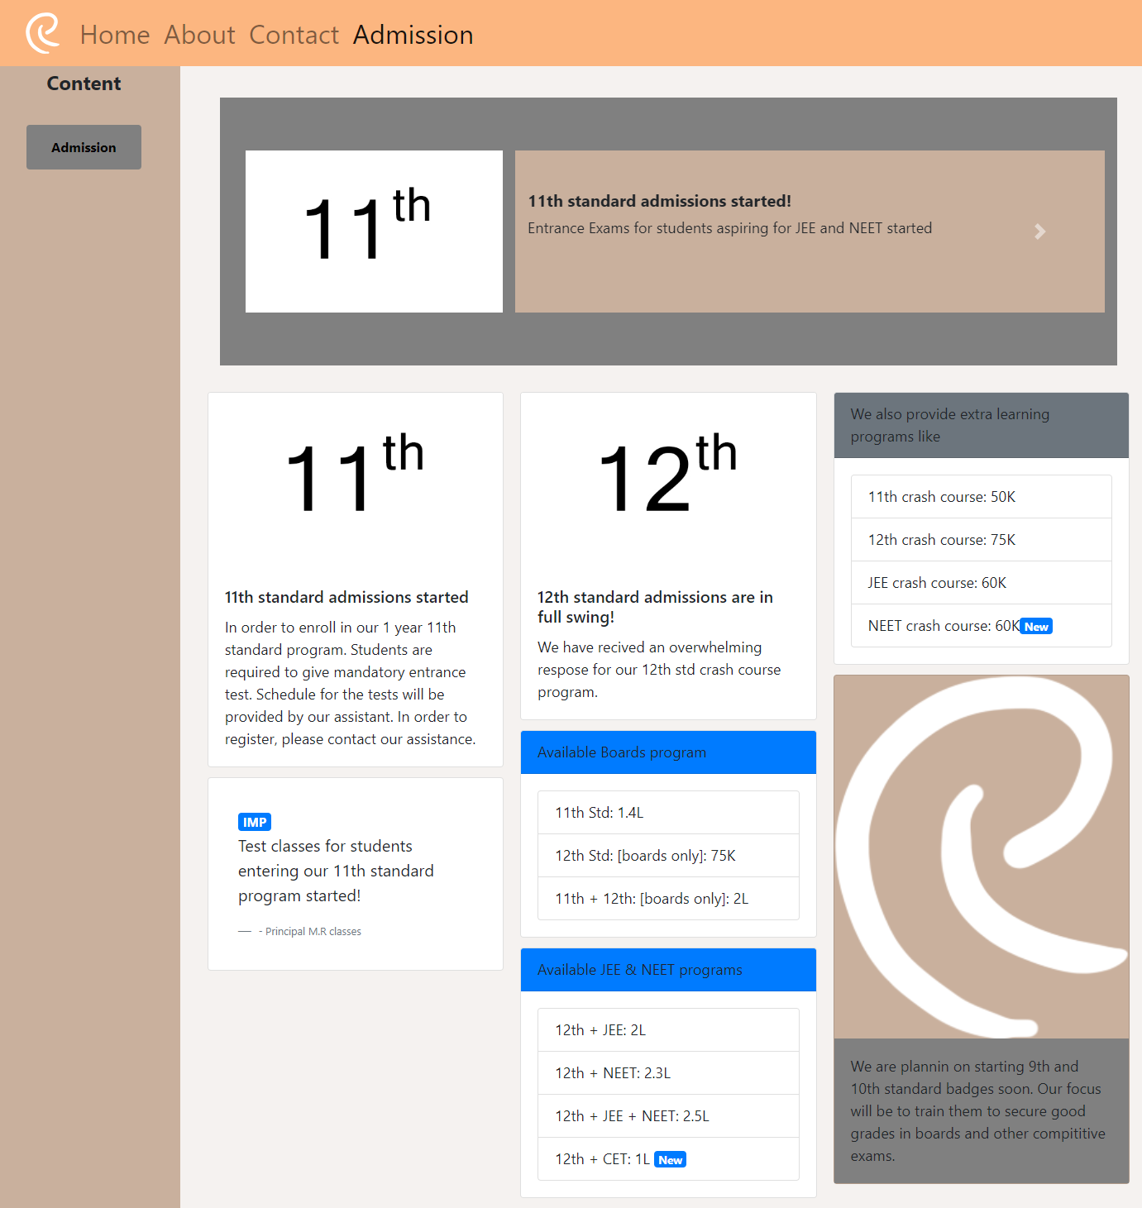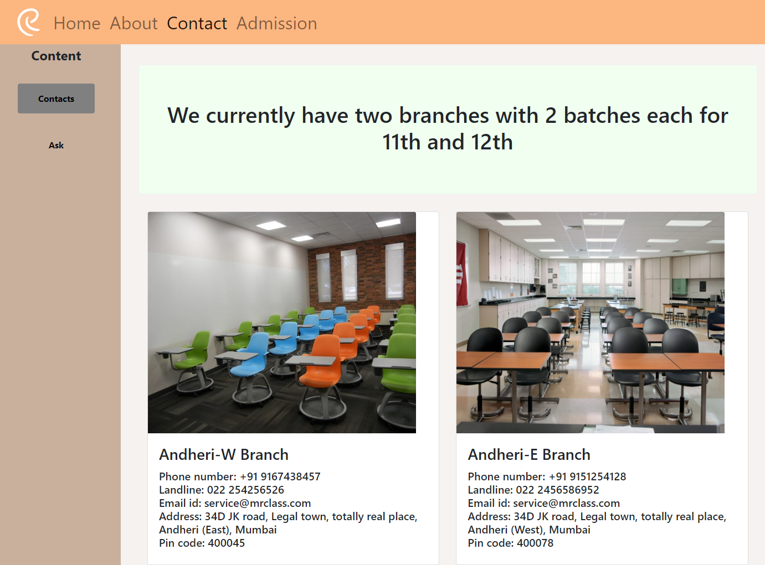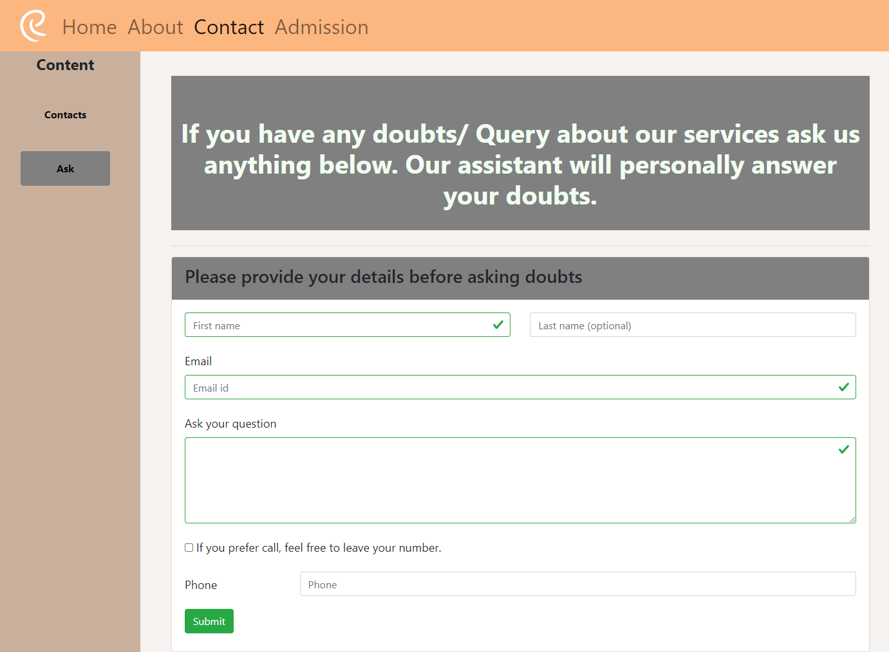

3. Conclusions

* Results we obtained from our project was fascinating.
* Features of the project:
  + A web portal that can better communicate the services that our Classes provides to any potential customers.  
    Some of its features include:  
    - A method to contact us with a form available at the contact page  
    - The ability to learn about the admission process and submit an online application  
    - An extensive catalogue to showcase our professors  
    - An extensive catalogue to showcase our courses
* Shortcomings of the project:
  + None, since we implemented everything, we sought out for
* We would have made no different choice since we are just doing what we want but in hindsight if we wanted to spend more time on it we may refine the animations a bit more

4. References

* Research handbook on innovation governance for emerging economies : towards better models. Kuhlmann, Stefan. Cheltehnham, UK. 27 January 2017. ISBN 978-1-78347-191-1. OCLC 971520924.
* ^ Roser, Max; Ortiz-Ospina, Esteban (2019). "Primary and Secondary Education". Our World in Data. Retrieved 24 October 2019.
* ^ [1], Ganesh Harpavat, International Schools, on Perseus
* ^ Online Etymology Dictionary; H.G. Liddell & R. Scott, A Greek-English Lexicon
* ^ School, on Oxford Dictionaries
* ^ σχολή, Henry George Liddell, Robert Scott, A Greek-English Lexicon, on Perseus
* ^ Bentley, Jerry H. (2006). Traditions & Encounters a Global Perspective on the Past. New York: McGraw-Hill. p. 331.